Exercise 1: Setting Up JUnit Scenario: You need to set up JUnit in your Java project to start writing unit tests.

Steps: 1. Create a new Java project in your IDE (e.g., IntelliJ IDEA, Eclipse). 2. Add JUnit dependency to your project.

If you are using Maven, add the following to your pom.xml: junit junit 4.13.2 test

3. Create a new test class in your project

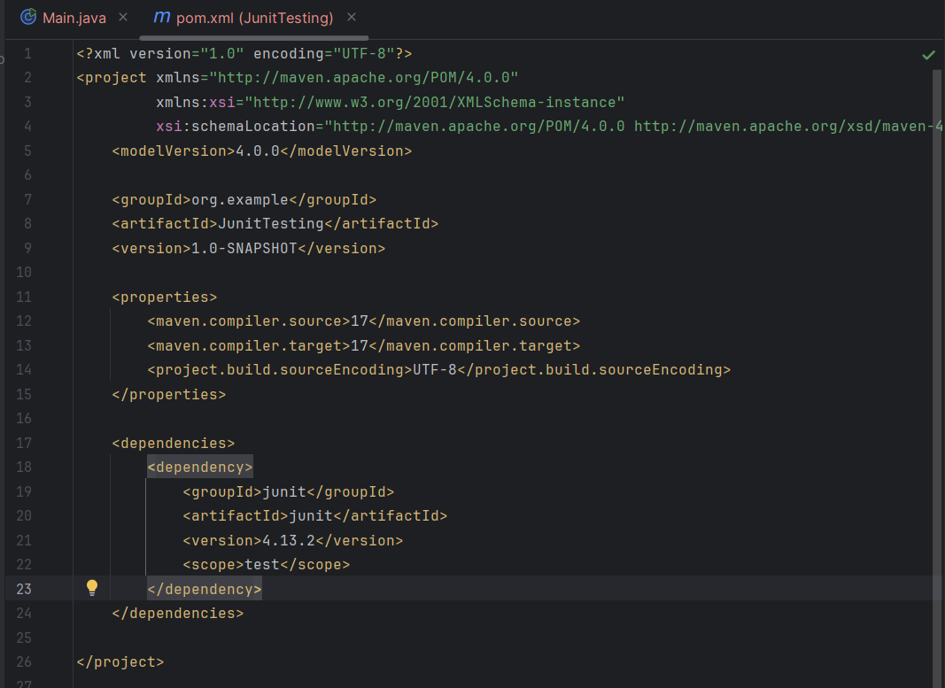

Test Class - 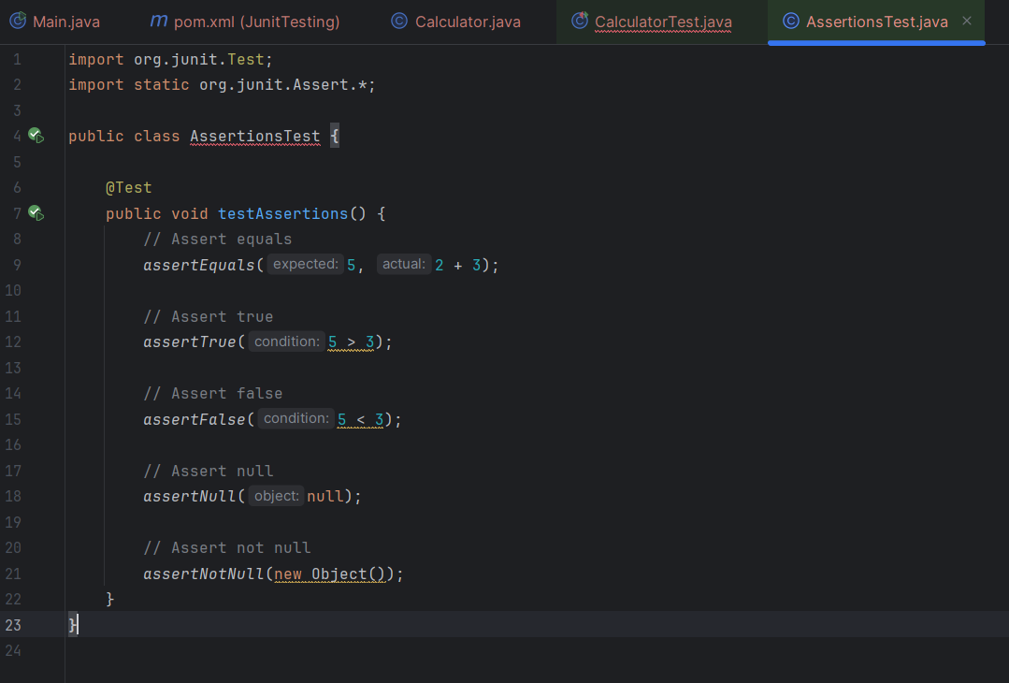

Exercise 3: Assertions in JUnit Scenario: You need to use different assertions in JUnit to validate your test results.

Steps: 1. Write tests using various JUnit assertions

